Magic sudoku

Chandan has drawn a square of size N2 x N2 on a piece of cross-section paper and divided it into N2 smaller squares of size N x N. Ram wants to write numbers from 1 to N2 in the squares of the paper, (let's call them cells) in order to obtain a magic square. A magic square is a square in which:

1. There is one in the left upper cell.

*2. There are no repeating numbers in any column.*

*3. There are no repeating numbers in any row.*

*4. There are no repeating numbers in any of the smaller squares.*

5. If we swap two smaller squares having a common side, then we obtain square satisfying properties 2 to 4.

Ram has already written several numbers. Determine if it is possible to fill the remaining cells and obtain a magic square.

Example:

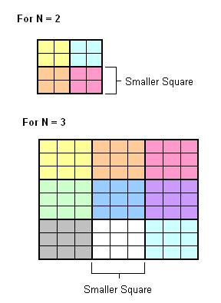 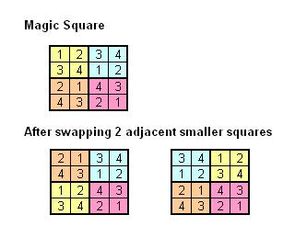

**Input Format**

Your function will take a multi-dimensional integer array depicting the square matrix (N2 x N2).

**Constraints**

1<= N <=20

**Output Format**

You need to return output as 1, if the magic square is possible with the given input, 0 otherwise.

**Sample Test case 1**  
Sample Input

4  
4  
0 0 0 0  
0 0 0 0  
0 0 0 0  
0 0 0 0

Sample Output

1

https://pastebin.com/jUqtKW44